Steps:

1. clone this GitHub repo “<https://github.com/Deepthi-01997264/eco2_updated>“

2. email settings:

a. 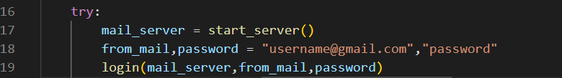

b. in ”run.py” at line 18, give an email address and password, better use a dummy account (gmail only).

c. go to your email account and click manage your google account button

d. go to security tab

e. remove two factor authentication if any

f. go to less secure app access and switch it on

3.google spread sheet settings

a. go to your google spread sheets homepage and create a spread sheet with name

“ECO2 Levels” {u can give any name but need to change accordingly in the gspread_api.py}

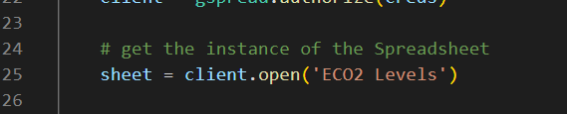

b. share the created google spread sheet with

[my-account@t-skyline-347415.iam.gserviceaccount.com](mailto:my-account@t-skyline-347415.iam.gserviceaccount.com)

4.execute run.py

a.cd “go to your cloned directory where run.py is present” in terminal

b. run with either commands below

**python3 run.py -u 300**

Or

**python3 run.py -u 300 -co2 1000 -email** [**jeomansang@gmail.com**](mailto:jeomansang@gmail.com)